WLSM documentation tool template

DATE INITIATED  YYYY / MM / DD | TIME INITIATED  : | FOLIO XX of XX | PATIENT IDENTIFICATION

Withdrawal of life-sustaining measures symptom based critical care
Instructions for Use
1. This is a template for a nursing documentation tool to chart events, vitals, and medication administration from the time of withdrawal of life-sustaining measures (life support) and death, transfer to a unit outside the ICU or when 12 hours has lapsed. This template may be used, or it may inform the development of a similar organizational tool for your local unit. Units may want to consider the use of additional RT and or MD documentation tools.
2. Once this document is invoked, a notation in the usual ICU charting document (flowsheet or electronic charting) should be made to indicate that WLSM flowsheet charting has been initiated – e.g. “See WLSM flowchart”.
3. If a patient remains alive for an extended period of time following WLSM, usual charting is resumed and a notation should be made in both this flowchart and the usual chart to indicate the transition – e.g. “WLSM flowsheet ended”.
4. The minimum charting requirements are as follows:
a. vital signs are charted just prior to withdrawal and then hourly for the next 12 hours;
b. rationale for any bolus medication or change in infusion rate is included;
c. action plans (as detailed in the orders) should be copied on to page 2 of this document prior to withdrawal; and
d. time of death, declaring providers, and method of declaration must be charted on page 3.
5. If a symptom (listed A-K) is used to justify a bolus or infusion rate change, the letter corresponding to the symptom should be circled.
6. If additional narrative charting is necessary and does not fit on the flow chart, a number can be written and circled to indicate the reader should review the continuation of the note on page 3 of this document.
7. Symptom documentation supports ease of use and compliance. However, the use of validated scales such as BPS, CPOT and RDOS would provide additional value and more objective data. Programs should consider the use of validated scales.
8. Samples of pain, sedation and respiratory scales have been attached as an appendix on page 4.

Pre-WLSM Huddle
Date initiated | YYYY / MM / DD
Time | :
Attending | - MD □ RN  - Spiritual care | □ | RT

Item | Stopped at |  | Initials
 | Date | Time
Vasoactive agents / pressors | YYYY / MM / DD
Extubation | YYYY / MM / DD
Other | YYYY / MM / DD

WLSM Initiated

PATIENT IDENTIFICATION

Date | YYYY / MM / DD
Time | :

Time | Provider Initials | Vitals |  |  | Pain, Dyspnea and Discomfort Management Narcotic: Note: The Behavioral Pain Scale (BPS) and the Critical‐Care Plan  Observation Tool (CPOT) are valid and reliable and could be substituted |  |  |  | Agitation and Anxiety Benzodiazepine / Anxiolytic |  |  |  | Response to changes in drug administration, sedation/pain meds and other comments
 |  | HR | RR | BP | Respiratory Distress & Air Hunger | Pain and Discomfort | Infusion Rate | Bolus Dose | RASS  or  SAS | Other | Infusion Rate | Bolus Dose
 |  |  |  |  | Fearful facial expression  - Accessory muscle use  - Paradoxical breathing  - Nasal flaring  - Family concern | - Diaphoresis  - Rigidity  - Wincing  - Shutting of eyes  - Clenched fists  - Verbalizing / Moaning
 |  |  |  |  | A B C D E F G H I J K
 |  |  |  |  | A B C D E F G H I J K
 |  |  |  |  | A B C D E F G H I J K
 |  |  |  |  | A B C D E F G H I J K
 |  |  |  |  | A B C D E F G H I J K
 |  |  |  |  | A B C D E F G H I J K
 |  |  |  |  | A B C D E F G H I J K
 |  |  |  |  | A B C D E F G H I J K
 |  |  |  |  | A B C D E F G H I J K
 |  |  |  |  | A B C D E F G H I J K
 |  |  |  |  | A B C D E F G H I J K
 |  |  |  |  | A B C D E F G H I J K
 |  |  |  |  | A B C D E F G H I J K
 |  |  |  |  | A B C D E F G H I J K
- Continued in Folio #

WLSM Documentation Tool Page 2 of 4

DATE OF DEATH  YYYY / MM / DD |  | TIME OF DEATH  : |  | PATIENT IDENTIFICATION
DEATH WAS PRONOUNCED BY:
PHYSICIAN 1 PHYSICIAN 2
OTHER NOTES

*** The below table refers to numbered charting notes from page 2 of this document. ***
# | Note | # | Note
1 |  | 13
2 |  | 14
3 |  | 15
4 |  | 16
5 |  | 17
6 |  | 18
7 |  | 19
8 |  | 20
9 |  | 21
10 |  | 22
11 |  | 23
12 |  | 24
Post-WLSM huddle Charting healthcare practitioners
Date initiated YYYY / MM / DD  Time :  Attending ☐ MD ☐ RN ☐ RT ☐ Social work ☐ Spiritual care ☐ Other | Initials Name Designation

Examples of pain and sedation scales

Richmond Agitation-Sedation Scale (RASS)  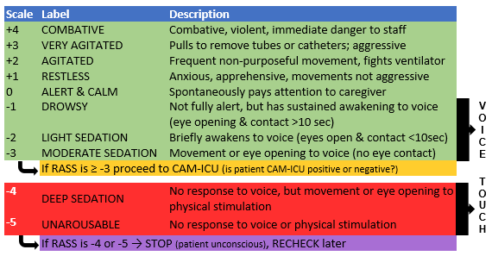  Sessler, et al. Am J Respir Crit Care Med 2002. 166: 1338-1344 Ely et al. JAMA 2003.286. 2983-2991 |  | Critical-Care Pain Observational Tool (CPOT)  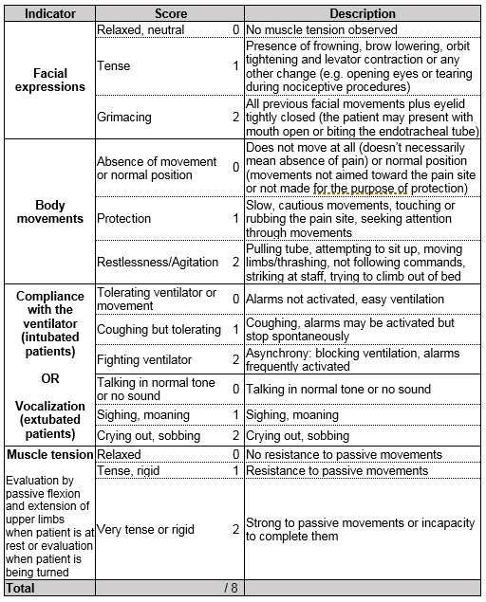  *Note: When a patient’s CPOT is >3, the team will evaluate pain sources and modify/enhance pain management. CPOT sensitivity = 86% and specificity = 78% (Gélinas C, J Pain Sympt Man 2009).  Adapted from Gélinas et al., AJCC 2006; 15(4):420-427). Reproduced with permission. For more information about the CPOT use, contact the author at celine.gelinas@mcgill.ca
Riker Sedation-Agitation Scale (SAS)
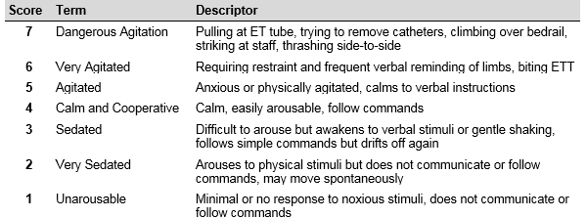
Behavioral Pain Scale (BPS)  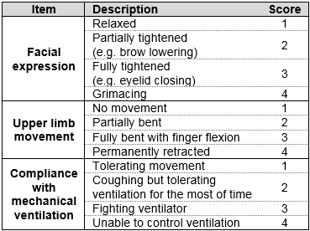  *Note: BPS score ranges from 3 (no pain) to 12 (maximum pain). | Respiratory Distress Observation Scale (RDOS)  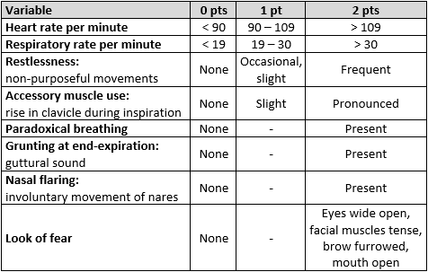  Journal of Palliative Medicine. 2010; 13(3): 285-290

